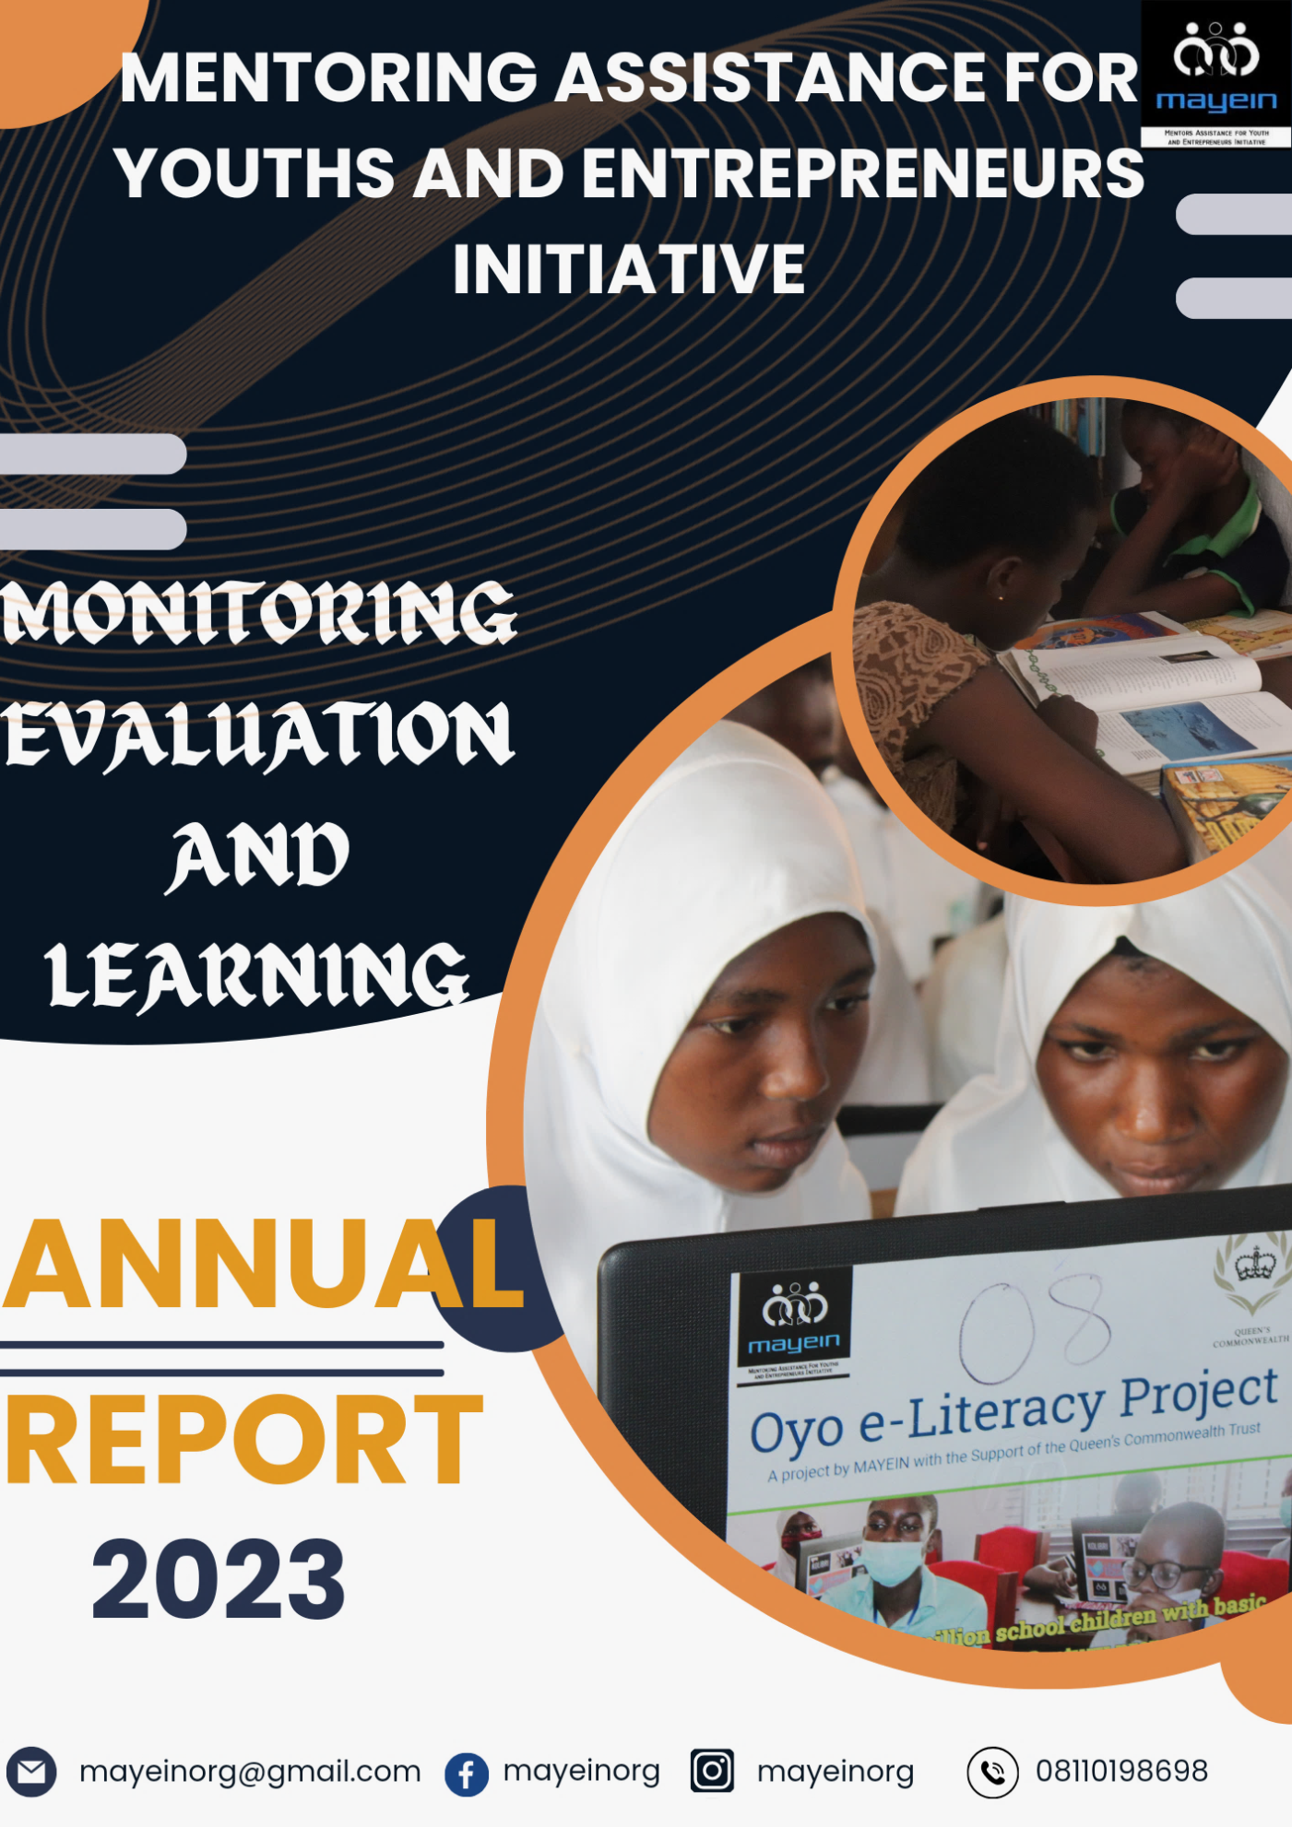

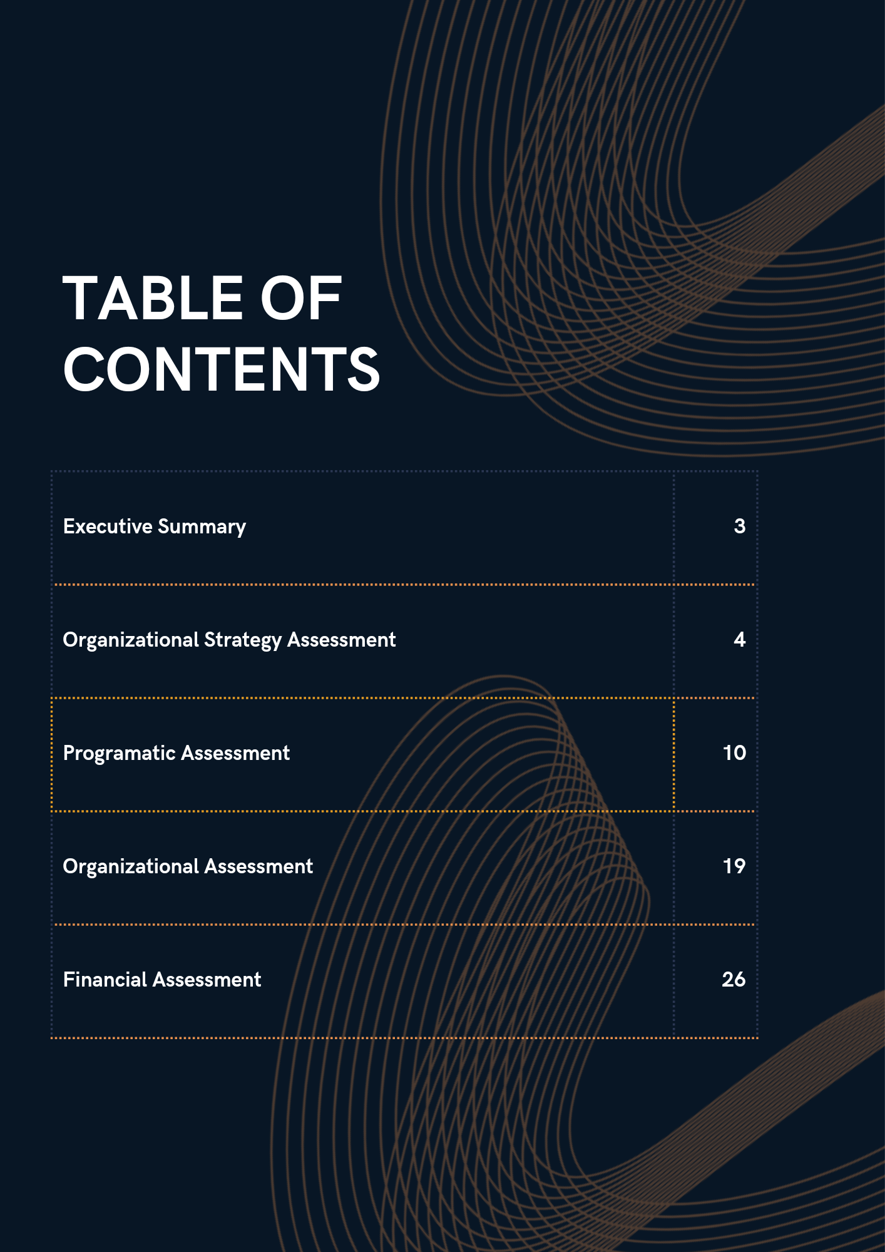

**EXECUTIVE SUMMARY**

Mentoring Assistance for Youths and Entrepreneurs Initiative (MAYEIN), a non-governmental organization headquartered in Oyo State, Nigeria, focuses on Positive Youth Development through the strategic advancement of SDGs 4, 5, 16, and 17. Established formally in May 2012, with registration No: CAC/IT/NO 52811, the Organization is governed by an 8-member Board of Trustees and advisory committee. MAYEIN’s mission is to lead strategies that advance inclusive quality education and lifelong learning, gender equity, and civic readiness for the attainment of positive youth development. We envision a country and continent whose young people are thriving in communities and correspondingly communities that are thriving because of young people. Since 2012, MAYEIN has impacted over 15,000 youth across Nigeria through a compendium of programs, campaigns, as well as direct services. Our main approaches to impact include research and learning, flexible spaces, partnerships and mentoring.

In achieving the goals and objectives stated by the organization, it is important to monitor all the processes involved, give feedbacks and evaluate the overall performances of the organization at the end of the year.

The end of the year Monitoring and Evaluation process of the organization is divided into 4 main categories.

* First, the evaluation of the execution process of organization’s strategy document.
* The second section contains the skeletal impact report of all the programs executed by the organization throughout the year.
* The third section, a comprehensive assessment of the organization in terms of its working systems as evaluated through the QCT adopted Organizational assessment tool.
* And lastly, the Finance Evaluation which will be assessed at the beginning of next year right after the external auditing process.

**ORGANIZATIONAL STRATEGY ASSESSMENT**

The strategy document titled “Sustainability and Growth Strategy” charts out the three main operational areas that will be the core of the organization’s activities in the period of 2023 - 2025, which would be the period of intense scale and growth. The implementation will be conducted in a way that optimizes institutional growth prospects through activities we already deem meaningful, in line with our identity, our values, and our strategic focus. The three focal goal areas thus refer to the above development logic and represent processes that work in sync, building on one another, and maximizing synergies enabled by their interrelatedness

At the start of the year, there was a strategic management meeting with Heads of departments. In the meet new organizations strategy document to be used for the next 3 years was discussed, broken down into strategies and deliverables drawn out of the three focal strategies.

Reports from various departments were collated and necessary information extracted to produce this final assessment document. This report shows a comprehensive level the organization is after the first year of implementing the stated objectives as derived from the strategy document.

| GOALS | STRATEGIES | OUTCOME | LEARNING/INSIGHTS |
| --- | --- | --- | --- |
| Increase and Diversify Organizational Income | Intensify Grant Seeking | No large grant secured for the year but a total of 6 grant applications were submitted for the year.  1 micro grant secured for the MLS project, 2 grant applications submitted (ACT Foundation grant and SOS children Village Youth development program) and still open while the other 3 were not granted. | * Efforts should be intensified on grant seeking by concerned departments. * Quarterly Monitoring of grant seeking processes should be taken seriously by MEL department * Active follow up of submitted grant applications * There should be a log where submitted applications are kept for reference purposes |
| New IGR and Investment base | This year MAYEIN started an investment with DE Influencer Global Concept Ltd. | * Steps should be taken by the organization to undertake more investment programs * There should be a formal consultation with experts/Firms before investments are made. |
| Development community engagement plan and recruit dedicated personnel | This was not achieved this year as no engagement officer was hired hence no plan was developed. | * Recruitment of a community engagement officer. * With the recruitment of a CEO, detailed community engagement plan should be developed |
| Pursue CSR and stakeholder partnerships: | A CSR mapping was done with the support of 1 of MAYEIN’s Board Members and actively follow-up will resume January 2024 | * No concrete CSR mapping done for the year. A more comprehensive CSR database is key to improved stakeholder’s partnership. * Development of strengthening guidelines. |
| Improved storytelling, brand and communications | **Communication plans:**  Communication plans in place, The storytelling calendar was reviewed and adopted in the first half of the year, constant posting on social media channels (Instagram and Facebook) | * The desk didn’t adequately serve its function of enlightening the guests about MAYEIN as there were no fliers to display or give out. * There was no communication desk at MAYEIN@10 * Recruitment of a dedicated communication staff would improve the organization’s branding and storytelling |
| **Partnership**  However, MAYEIN had the following media coverage:   1. 2 radio interviews on Agidigbo and JMP Bliss radio 2. 2 TV features – BBC and Channels TV 3. 3 print media coverages – Guardian, Radio Nigeria and Tribune 4. New month graphics and e-fliers shared throughout the year 5. Designed and printed brochures for the sponsorship/partnership drives. 6. A new partnership was formed with Johnvents Cocoa who provided product sponsorship during the Oyo Schoolgirls General Assembly. In addition, we had recurring product sponsors - both Fanmilk Nigeria PLC and Sumal PLC who provided products towards the General Assembly. 7. Communication’s Desk: A communication’s desk was created for World Book and Copyright Day with 2 volunteers who were busy with storytelling. | * No partnership was formed with any radio station. * To improve the organization’s branding, efforts must be made by the communications and Storytelling department to establish partnership with media (Television and radio) * Also there must be a communications desk for every program organized by the Organization. |
| **Production of Branded Items**:  Production of customized souvenirs. MAYEIN made customized pens for guests at the Schoolgirls General Assembly. | * The organization needs more branding materials like fliers, posters, banners, vest etc. to improve the branding of the organization * For programs sponsorship and branding, new partnerships need to be formed to drive sponsorship. |
| Organizational Sustainability | Continued use of the QCT Organization assessment tool | This year an organizational assessment workshop was held for staff where staff member were trained on the usage of the tool.  At the end of the year the Organization was assessed using the tool, the result analyzed in the next section | * The MEL lead of the organization should separate the assessment tool into departments for departmental heads to have the necessary information needed for the growth of their respective departments. |
| Integration of ESG/PEST models analysis within MAYEIN systems | An orientation session facilitated by the Executive director was held on the introduction of PESTLE analysis into the Organization reporting template which began to reflect in the weekly reports of staff and volunteers | * The introduction of PESTLE Analysis this year helped the organization to be abreast of current situations and strategies put in place to mitigate against such situations. * PESTLE analysis on weekly reporting should be taken more seriously by employees |
| Full transition to digitized work systems | In order to digitize work systems, official email was created for all staff, volunteer’s onboarding resources and training activities were also digitized | * Periodic workshop for staff on PESTLE * The adoption and operationalization of climate responsiveness guidelines in MAYEIN’s operations |
| Upgrade of current MEL systems | A MEL officer was recruited this year, MEL Plans for programs developed according to the MEL Policy and Insight and learning report shared with the management | * With the recruitment of a dedicated MEL officer, there was a better monitoring and evaluation process although there room for improvement. * Training needed by the department and the team on MEL Processes |
| Conduct bi-annual organizational assessment by independent assessor including review of organizational policy document | External organizational assessment not held this year but the yearly independent financial audit will be conducted at the beginning of the coming year. | * Plans should be in place next year for the bi-annual organizational assessment by independent assessor which would include reviewing of organizational policy documents |
| Programmes expansion and scaling | Carry out needs assessments | No needs assessment was carried out this year. | * The organization should take up more programs which is only possible after needs assessment has been carried out. |
|  | Engage NGO partners and Youth Corpers ambassadors across states | A youth corper from Osun state was engaged during the World book and Copyright Day program. Where students from the school he was serving joined the program virtually. | * An education ecosystem map needs to be developed * Extension of MAYEIN programs to other states with the assistance of Youth corper ambassadors |
|  | Consultation with community and stakeholder groups | MAYEIN engaged with 2 stakeholder groups. First was during the experiment dialogue with parents of the GED participants while the second was during the school girls’ general assembly where different educational stakeholders, education officers, government officials Head of schools, government bodies and parents were present.  Also Alaka Community where the Youth center is located engaged in a cordial relationship with the community by attending community meeting regularly | * A major stakeholder consultative meeting was organized on a mission area (inclusiveness) * Stakeholders meeting on others mission areas of the organization should be organized. |
|  | Award of micro grants and Training of Trainers approach | No micro grant was awarded this year, however 2 train-the-trainer sessions were held. First with the Childs Protection Network (CPN) where 5 different organizations were trained on how to produce reusable sanitary pads.  The second train-the-trainer was held before the commencement of the GED project in schools where 2 facilitators were trained on the project’s scope | * It is important to have training of trainer sessions before the start of a project/program. * No program/project should be executed without a training for the facilitators * Youth programs (HEED) hosted by the organization should be incentivized in form of Micro grants for outstanding youths. |
|  | Increase programmatic staff and volunteers | Report from the Human Resources department recorded 5 volunteers and 1 intern worked with the organization across all programs with 2 on GED, 1 on the MLS Project, 2 on the Oyo e-Literacy project and 1 current working on the administrative part of programs department. | * The presence of volunteers and interns really helped the programs department in projects execution. * Hiring of staff in specific roles like youth lead, Gender lead and a community engage officer will definitely improve programs execution. |

**SECTION 2**

**PROGRAMATIC ASSESSMENT**

Throughout the year 2023, MAYEIN worked on 8 programs and the impact of each program is shown below. A more comprehensive impact of the programs is already outlined in the programs impact report for individual program. 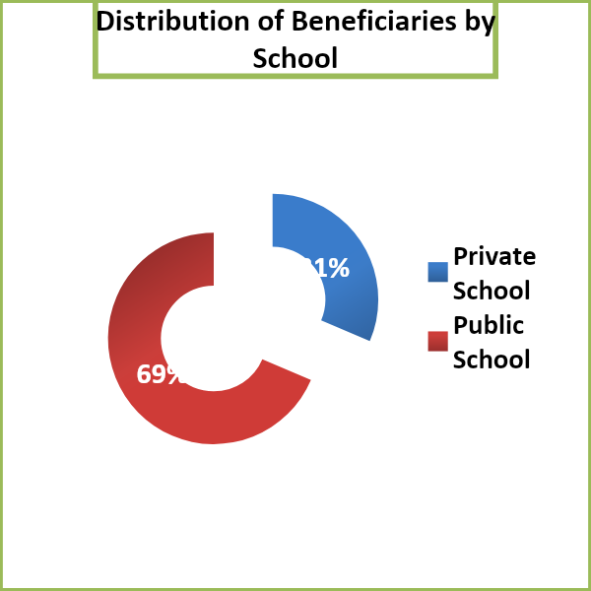

1. Oyo e-Literacy Project
2. World Book and Copyright Day Program
3. International Literacy Day Program
4. Hub For Entrepreneurship And Employability Development Programs

* International Youth Day Program
* MAYEIN Agri-Business Program
* Graphics Designing Program

1. Summer Camp Program
2. Girls in Education Dialogue Project
3. MAYEIN Youth Centre
4. Mobile Library in Schools Project

**OVERALL DEMOGRAPHICS FOR THE YEAR**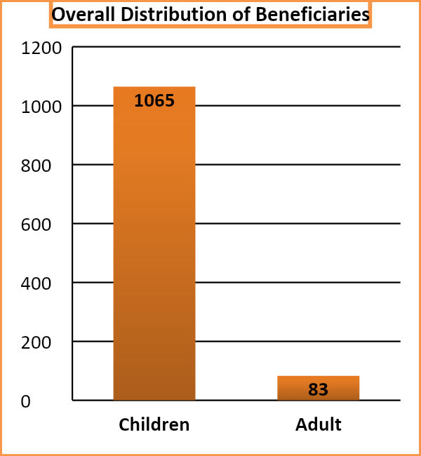

| Total number of Children Beneficiary | 1065 |
| --- | --- |
| Total number of Adult Beneficiary | 83 |
| Total number of Youths Engaged | 24 |
| Total number of Public schools reached | 25 |
| Total number of Private schools reached | 11 |
| Number of New Schools reached | 28 |
| Out of school Beneficiaries (University undergraduate) | 8 |
| Number of Orphanage Homes reached | 1 |
| Number of new communities reached by the MYC | 2 |
| Total number of communities reached by the MYC since inception | 29 |
| Total number of communities reached by the organization. | 58 |

| S/N | PUBLIC SCHOOLS | PRIVATE SCHOOLS |
| --- | --- | --- |
| 1 | St. Gabriel Commercial Secondary School | GOFAMICHS |
| 2 | Community High School Adamasingba | Milestone College |
| 3 | Bashorun Ojoo High School | Peculiar international School |
| 4 | Community Grammar School Mokola | Posit College |
| 5 | Community High School Samonda | First Class International College |
| 6 | Ansarudeen High School Eleyele | American Christian Academy |
| 7 | Army Day secondary School | Pampers International school Lekki |
| 8 | St. Brigis Seconndary School | Bodija International College |
| 9 | Ojoo High School | Reflective International College |
| 10 | Samuel Adegbite Memorial Grammar School | Honeycomb Unique College |
| 11 | Community Grammar School Akingbile | D and D Royal Family School |
| 12 | Jerico High school |  |
| 13 | Ikolaba High School |  |
| 14 | Community Secondary School Olopomewa |  |
| 15 | Bashorun High School |  |
| 16 | Ikolaba Grammar School |  |
| 17 | Estate High School |  |
| 18 | Islamic Day High School |  |
| 19 | Al Ghayah College |  |
| 20 | Community High School Sasa |  |
| 21 | Orogun secondary school |  |
| 22 | IMG Grammar School |  |
| 23 | Oba Akinbiyi Model College |  |
| 24 | Community High School Agbowo |  |
| 25 | Methodist Secondary School. |  |

**List of Beneficiary Schools**

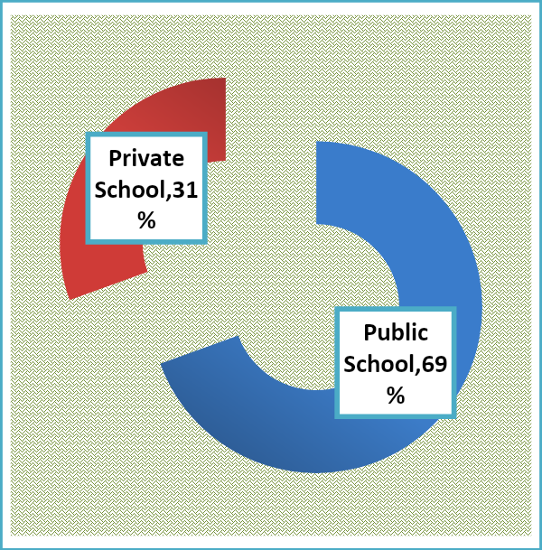

**OYO E-LITERACY PROJECT**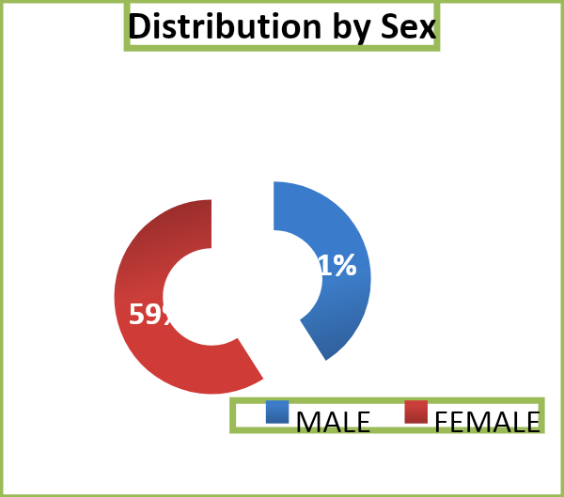

The goal of the project is to empower disadvantaged school children with basic computer literacy skills through practical ICT lessons delivered round Oyo State (public) secondary schools using a fully equipped mobile computer classroom otherwise referred to as ‘digital buses’ so school children can effectively participate in 21st century formal systems and be future ready. Four different phases of the project were held with 16 participating schools across Ibadan (10 public schools and 6 private schools) where a total of 226 students gained basic computer literacy skills. Also, 5 teachers enrolled for the program and were trained at Army Day secondary school using the same training module.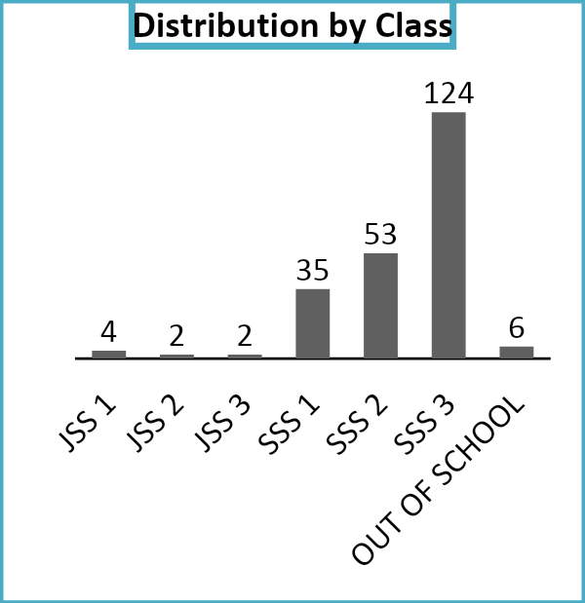

**Key Impacts**

* 226 school children from 4 phases and 5 teachers trained and exhibited increase in knowledge of desktop navigation, identification of various parts of a computer/laptop
* 226 school children and 5 teachers demonstrated skills in operating some computer programs like Microsoft Word and Microsoft Power point
* 226 participants gave an engaging presentation using self-prepared Power point slides.

**Insights and Recommendations**

* The project achieved 87% of its target population (226 out of 300). Therefore, plans should be made by programs department meet the targeted number of beneficiaries.
* Conduction of internet search which is a part of the project’s module was not taught in most of the phases of the project. Therefore, a review of the manual is important before the program commences next year
* Teachers program should preferably be held in the teachers’ hub to increase the seriousness of the participants.

**WORLDBOOK AND COPYRIGHT DAY**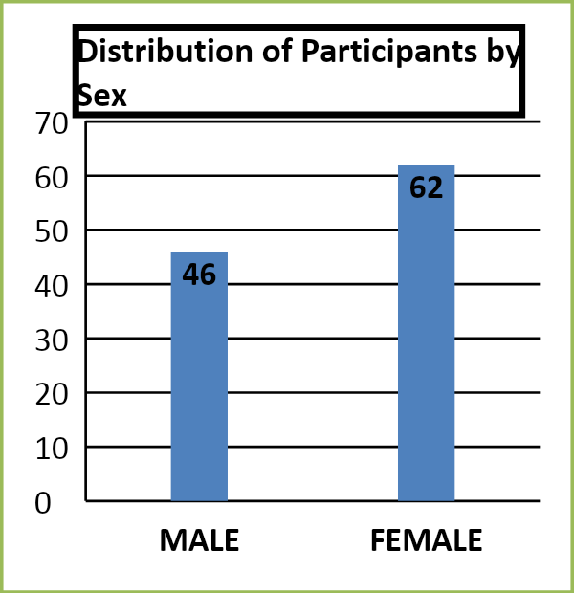

The goal of this program is to promote reading culture, encourage book appreciation, improve young people’s problem solving, cognitive capacity, creative writing and narrative skills of young people in Africa. Before the event, an online competition was held with a total of 5 entries from Oyo and Kwara state. During the program, 20 students from First class International College, Osun State participated virtually. The live event had a total of 108 secondary school students from Ibadan, Oyo State to give a total of 133 participants.

**Key Impacts**

* 108 participants experienced reading as beyond an academic activity at the program. 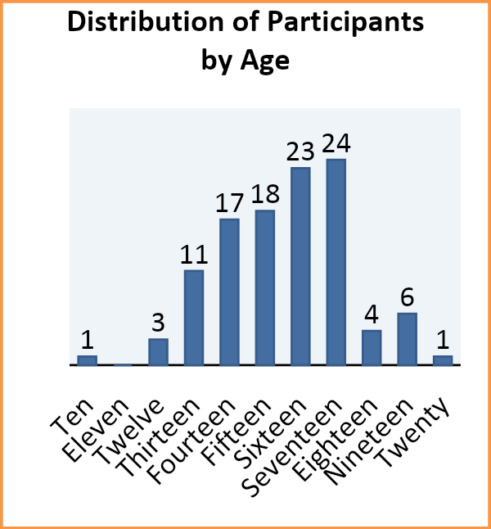
* 100% of the participants’ literacy (Speaking and Writing) skills were developed.
* There was also an improvement the creative writing skills of participants from 55% to 81%
* 100% of the participants were able participate in literacy games like Scrabbles, Books-to-Comic, Speed Authoring and Book-A-Thon as against the 49% that hadn’t participated before the program.

**Insights and Recommendations**

* There should be more facilitators and Judges during the program
* More authors should be invited for the program.
* Live Media coverage of the program.
* The program should scale to accommodate participants from other states in Nigeria

**INTERNATIONAL LITERACY DAY**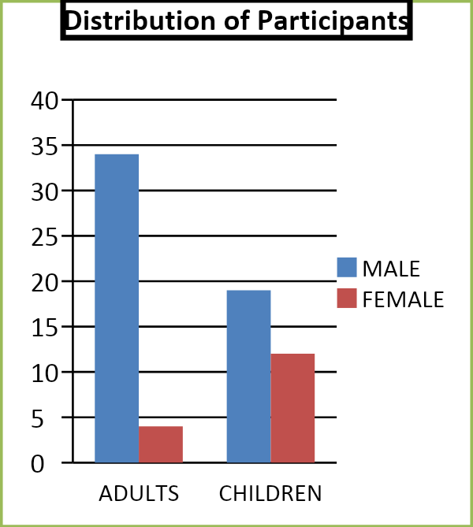

A MAYEIN sensitization project organized to educate low-income parents on the importance of literacy support services such as the MAYEIN Community Youth Centre in Alaka, Ojoo, Ibadan.

**Impacts**

* A sensitization program held with parents in 4 different tricycle parks in Ojoo, Ibadan on the importance of education and literacy to a child’s development.
* 38 adults enlightened on the importance of educating a child and also informed about the MAYEIN Youth center located in Alaka community.
* 31 children from the youth center sensitized on the importance of education and Literacy

**Insights and Recommendations**

* Sensitization programs should be intensified to reach a larger population
* Establishment of more community centres across the state
* Attention should be shifted to sensitizing parents in rural areas
* More literacy programs should be planned for children in communities through the youth center.

**HUB FOR ENTREPRENEURSHIP AND EMPLOYABILITY DEVELOPMENT PROGRAMS**

1. **INTERNATIONAL YOUTH DAY**: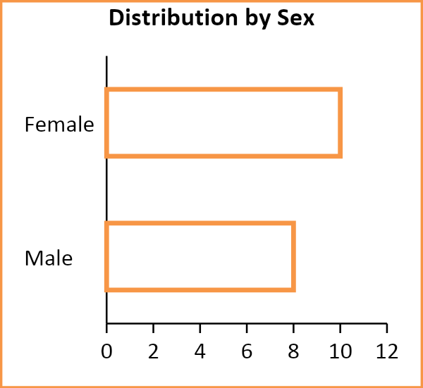

A MAYEIN project seeking to commemorate the international Youth Day by empowering 20 youths with soft skills for job readiness and entrepreneurial thinking, in Ibadan, Oyo State, Nigeria. The goal of the project is to train 20 youths on skills required for Job readiness and developing of entrepreneurial mindset. The program was attended by 18 participants from various sectors of the economy.

**Key Impacts**

* 100% of the participants trained on skills necessary for skills and job readiness
* 100% of the participants trained developing entrepreneurial mindset

1. **MAYEIN AGRI BUSINESS**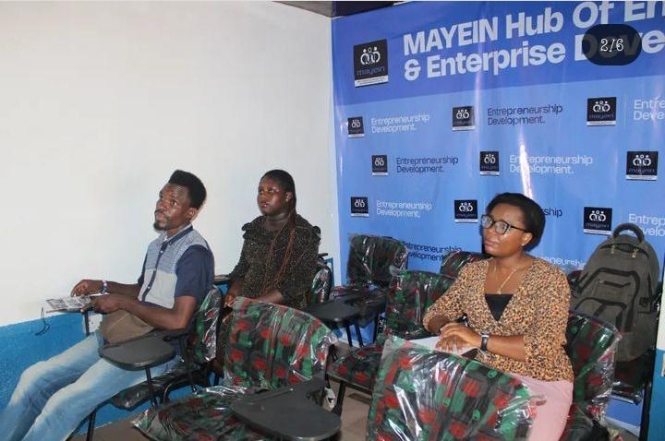

The MAYEIN Agri-Business training took place at the ring road space with 3 participants. The Goal of the program is to equip agriculturally oriented youth with the necessary skills needed for success in the sector.

**Key Impacts**

* Participants were introduced to Agri-Business
* Participants were trained on ways of developing agricultural business plans
* All Participants trained on effective farm management
* Participants introduced to snail and catfish farming

1. **GRAPHICS DESIGNING**

The graphics designing program is designed to equip young minds with basic designing skills necessary for self-sustainability. A total of 3 participants are currently being trained. At the end of the training, participants will be able to:

* Design graphics with a phone application called Canva
* Understand and apply the principles and elements of design.
* Use Corel Draw as a tool for graphics designing

**Insights and Recommendations**

* Micro grants can be awarded to young entrepreneurs to start up their enterprise.

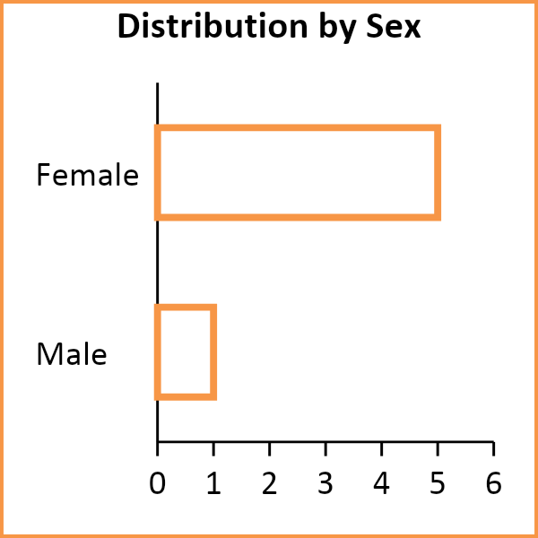

**SUMMER CAMP**

The summer camp program was organized to deliver an exciting experience from designed camp activities like pastry, Art, creative writing, drama and public speaking. 6 campers with an age range of 6-12 benefited from the program which lasted for 6 weeks.

**Key Impacts**

* 100% of the participants experienced fun and excitement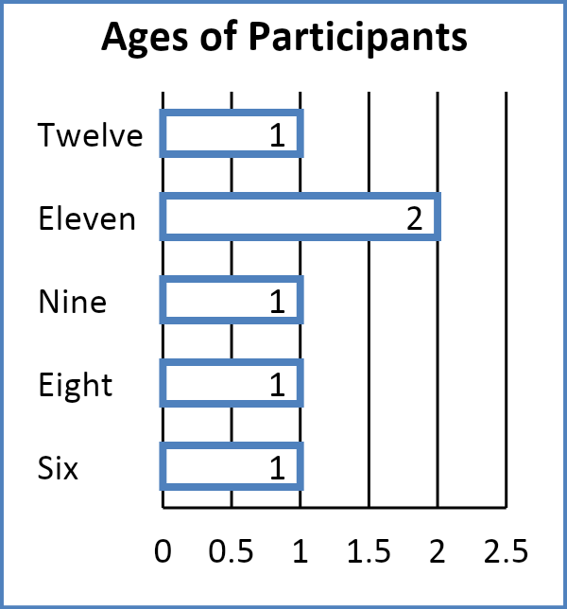
* 100% of the participants reported Physical development through dance and other physical activities.
* Increase in expression and presentation skills Knowledge, critical thinking and reasoning.

**Insight and Recommendations**

* Awareness about the program should be intensified to increase the number of beneficiaries.
* More fun and exciting activities should be added to the program

**GIRLS IN EDUCATION DIALOGUE**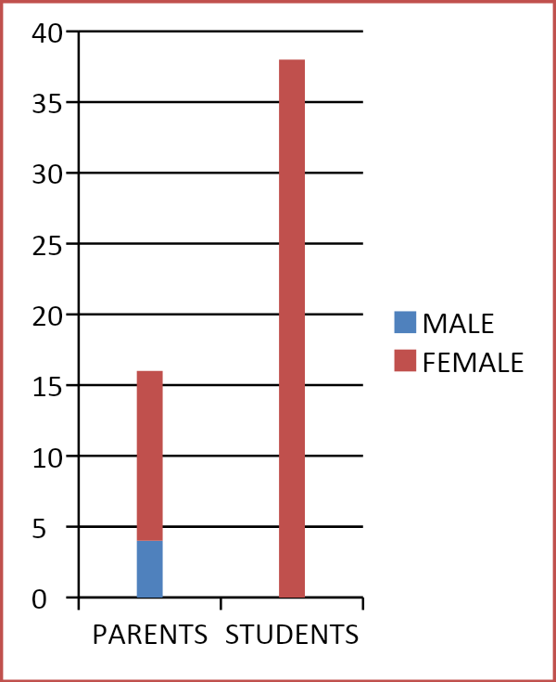

The goal of the GED project is to empower schoolgirls to exercise their agency and influence systemic practice whereby decision makers and stakeholders within education planning recognize and incorporate girls’ views.

**Key Impacts**

* 38 school girls from 4 public schools trained to exercise their agency and influence systemic practice
* 38 school girls trained on how to effectively identify their rights and communicate their needs to those in power
* 38 school girls from 4 public schools trained to Identify and practice strong communication skills
* Understanding Public Speaking and the steps to delivering a good Speech
* 16 parents trained on how to effectively engage and communicate with girls.
* 16 parents/Guardian also trained on how to consider their female children when decisions are made
* 123 students from 8 public schools in Ibadan participated in the general assembly

**Insight and Recommendations**

* Stakeholders’ training should well planned to reach out to parents of almost if not all of the school girls.
* Cordial relationship should be formed with schools participating in the program to ensure smooth running of the project without interruption.

**MAYEIN YOUTH CENTRE**

The MAYEIN Youth Centre opened for 139 days throughout the year with a total reoccurring attendance of 2775 users. This year the MYC recorded 50 new registered users to make up a total of 280 registered users. 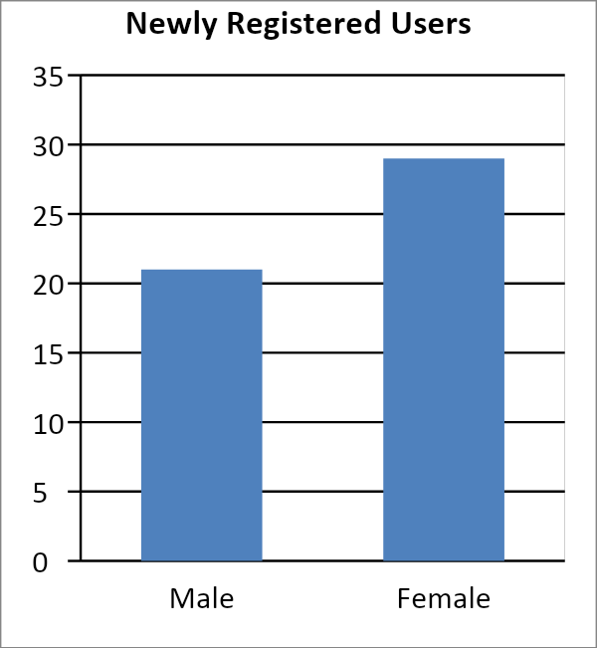

**Key Impacts**

* Library Users Soft skills development through a scheduled monthly theme
* Weekly read aloud session
* Weekly Spelling bee competition.
* Participants learnt new words on weekly basis from the spelling bee competition
* 2 phases of Oyo e-literacy project where 36 participants gained basic digital skills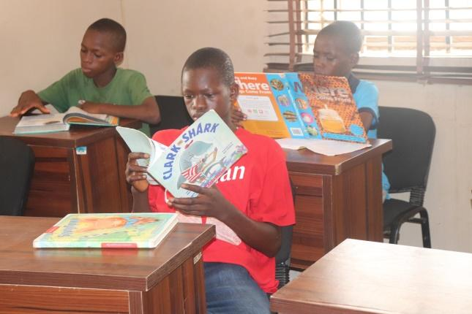
* 5 participants gained skills required for black soap production.

To wrap up activities for the year at the youth center, an end of the year program was held which centered on the role of mentoring in a child’s life. A total of 169 participants attended the event where they all were exposed to the concept of mentoring and its effects on the development of a child.

**Other Impacts**

* All participants were introduced to the concept of mentoring
* All participants experienced a type of mentoring (Peer Mentoring) with students from the American Christian Academy.

**Insights and Recommendations**

* Donation of books and other literacy items to the MAYEIN youth center Alaka
* Establishment of more youth centers
* Donation of materials and equipment for vocational skills trainings.

**MOBILE LIBRARY IN SCHOOLS**

The MLS program is targeted at students in public secondary schools with the goal of improving the literacy skills of the participants. The first phase of the program ended in November in 5 different schools in Ibadan. Before the commencement of the project, an evaluation test was administered to students from the school to select suitable participants for the project. After selection, a big dictionary donated by Inspiring the future Initiative was given to each selected students. 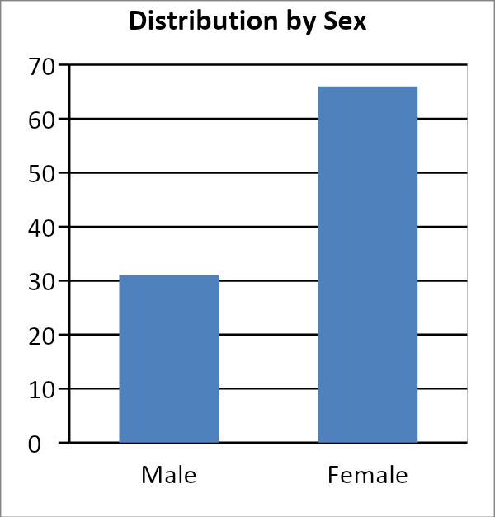

**Key Impacts**

* 97 students trained on how to use to dictionary as a tool to literacy development.
* 97 students on the path of improving their literacy skills

**Insight and Recommendations**

* The planning of the program should be more appropriate for better execution process most especially schools readiness and support for the program

**SECTI0N 3**

**ORGANIZATIONAL ASSESSMENT**

The organization was evaluated using the adopted QCT organizational assessment tool and the findings explained. Based on the recommendation of the tool, the grading system is based on the descriptions below.

| **Organisational Assessment Rating** | **Description** |
| --- | --- |
| **(A) Advanced Capability & Capacity** | The organisation has strong capability and capacity within this area and demonstrates good practice in the majority, if not all, of the elements noted within the definition of advanced capability.  Minimal externally provided capability and capacity building required. |
| **(B) Established Capability & Capacity** | The organisation has established capability and capacity within this area and demonstrates most of the elements noted within the definition of established capability.  Some capability and capacity building would help reinforce the organisation’s current established capability and support progression to an ‘Advanced’ rating. |
| **(C) Emerging Capability & Capacity** | The organisation has emerging capability and capacity within this area and demonstrates most of the elements noted within the definition of emerging capability, or an absence of key elements noted within ‘Established’ and ‘Advanced’ ratings.  Substantial externally provided capability and capacity building required in this area, without which it may be challenging for the organisation to achieve the transformational change that will enable attainment of an ‘Advanced’ rating. |
| **(D) Minimal Capability & Capacity** | The organisation has minimal capability and capacity within this area and demonstrates most of the elements noted within the definition of minimal capability, or an absence of key elements noted within ‘Emerging’, ‘Established’ or ‘Advanced’ ratings.  Substantial externally provided capability and capacity building required in this area, without which it is likely to take some time for the organisation to achieve the transformational change that will enable attainment of an ‘Established’ or ‘Advanced’ rating. |

|  |  | **GRADE** | **REMARK** |
| --- | --- | --- | --- |
| **GGGGG**  **Governance** | Legal | A | Registered with required national bodies, including with tax authorities. Full compliance with tax and reporting requirements under the registration. Written constitution exists and is relevant. Organization has been registered for over 5 years. |
| Board engagement | A | The Board may be missing certain key skills e.g. Finance. Some Board members fully engaged, typically a few Board members are much more active. Unclear division of responsibilities at Board level. |
| Board support & challenge | A | Board challenge of the Executive is lacking, and the Board is often used to ‘rubber stamp’ Executive decisions – or conversely there is minimal active support by the Board. |
| Risk management | B | Only a few Board and Executive members understand key risks and risk management. No formal processes exist to identify and review risks, although there may be infrequent identification of risks. Risk analysis does not inform how the organisation acts, and there is a history of fire-fighting issues.. Board members should have a structured functioning documented system for risks management |
| Leadership communication | B | Employees know the vision, mission and strategy of the organisation – and can clearly articulate how their work impacts upon delivery of the organisational strategy and how it has fed into their annual business plans, and day-to-day activities. |
|  | B | Anti-bribery/ fraud/ corruption, whistleblowing and conflict of interest policies have been drafted and may have been approved by management/ board but may not have been fully operationalised. Some staff are not aware of the policies.  Informal anti-bribery, whistleblowing and conflict of interest procedures may be in place. |
| **Safeguarding** | Policy | A | Robust operationalised safeguarding policies and procedures in place, including a Safeguarding Policy and Code of Conduct which references safeguarding expectations, which have been reviewed by a safeguarding expert / organisation, and approved by your board and publicised to all staff, associates, partners, children and communities |
| People – Internal | A | Through the development of locally appropriate materials those who come into contact with the organisation, whether beneficiaries or others, are all aware of the organisation’s safeguarding policy and who to report a concern or incident to, and have evidenced that this works through reported and appropriately resolved incidents. |
| People – External | B | The organization needs to routinely engage with other organizations on safeguarding processes. |
| Procedures – Mainstreaming | C | The organisation on occasion undertake safeguarding risk assessments and mitigation strategies, and a number of team members are familiar with how to assess safeguarding risk.  The organisation have integrated some safeguarding measures within existing processes and systems (budgeting, strategic planning, recruitment, programme management, performance management etc.) Safeguarding risk assessments should conducted regularly and safeguarding measure be fully integrated within existing processes and systems |
| Procedures -  Mapping & Disclosures | A | The organisation has undertaken a comprehensive localised safeguarding mapping exercise which they have triangulated and are confident about what safeguarding services could be offered.  The organisation has a comprehensive documented process for managing disclosures, escalating internally and undertaking investigations which has been tested and refined |
| Accountability | B | The organisation monitors compliance with safeguarding policies and procedures annually, and has limited processes in place to learn safeguarding lessons and adapt.  A limited annual safeguarding audit is undertaken but the findings may not be reported in the organisational annual report.There should be a robust annual review of policy and practice in light of lessons learnt and latest best practice. |
| **Strategy and Business Planning** | Strategy – Compelling and differentiated offer | A | A clear need (problem) has been identified, within a particular audience, and solution offered that addresses the need. There is a clear point of differentiation offered by the organisation with clarity as to landscape (competitors, collaborators). All is supported by sufficient relevant evidence and analysis. The offer is compelling. |
| Strategic Offer – Financial Sustainability | A | The proposed solution represents an affordable and value for money offer to those to whom it is marketed. The size of the ‘market’ is sufficient for the solution to become sustainable. The fundamental assumptions to support sustainability are reasonable and supported by actual statistically valid evidence.  Robust and timely sustainability modelling is conducted including with consideration for opportunity costs. Business plans are prepared and are well researched and are evidence based with accompanying sensitivity analysis. Performance of the income generating activities is monitored and milestones known, for instance, whether the activities are profitable, break-even or on target. |
| Strategic Plan – Coherent plan | A | Robust, logical plan developed that draws directly from the strategy and is clear on impact, resourcing requirements (cost and people), timescales and sequencing. Clear KPIs identified. |
| Strategic Plan – Execution | A | Execution of strategic plan is undertaken in accordance with the timescale, resourcing and sequencing identified in the strategic plan. KPIs are regularly reported on, attainment evidenced, and lessons learnt and adaptive management response evident. |
| **Programmatic** | Programmatic staff and support | B | The team members (staff or volunteers) delivering on technical aspects are suitably experienced and qualified although there may be capacity issues. There are individuals (either within or outside of the organisation) with the requisite skills that team members could readily turn to for advice. |
| Operational work plan and delivery | B | An operational workplan exists and helps guide delivery, although there may be some activities that happen outside of the workplan and it may only be partially used to monitor performance. A project management methodology is likely to have been applied. |
| Programmatic reporting | A | Programmatic reports with quantitative, qualitative and risk information and analysis are prepared regularly and in a timely manner to inform learning and adaptive management and issued to key internal and external stakeholders. |
| Programmatic learning and evaluation | B | Good monitoring, evaluation and learning (MEL) capability but there may be capacity limits. An organisational Impact or MEL framework exists. There is a periodic and formal process whereby key learnings are captured and evidence of resultant adaptive management with learning feeding into revisions to programme design. |
| **Financial Management & Systems** | Finance Team & Non-finance staff | B | The finance team contains an individual with limited financial management experience. Segregation of duty issues likely to exist. Non-finance staff who have financial duties (e.g. budget holders) see finance as separate from their responsibilities – including budget ownership and management.  Employment of dedicated finance officer will improve the department |
| Financial Processes & Systems | C | A basic chart of accounts has been adopted or developed, but the accounting system is unlikely to be automated and Excel spreadsheets are likely to be used. Income and expenditure are recorded periodically and unlikely to be recorded on a daily basis.  Cash accounting is likely to be adopted. |
| Internal Controls | A | Internal controls exist to address key high and moderate risks, including as a minimum adequate segregation of duty, monthly bank reconciliations, variance analysis reporting. There are set controls and guidelines on petty cash and programmatic activity floats and they are fully complied with. Journal postings are limited and all approved. There is sufficient senior review when required. Sufficient documentation is held in an organised manner to provide an audit trail. |
| Budget | A | Organisational, and where relevant project specific, budget(s) have been developed and approved although not always in timely manner. Some income/expenditure may occur outside budget. Budget variance analysis is sufficient. Budgets are reviewed during the year although the budget revision process may be basic. Budget holder ownership could be strengthened. |
| Financial Monitoring & Reporting | A | Expenditure reports can be developed upon request but are not routinely prepared although unlikely to be timely or have sufficient analysis for an uninformed reader. Unlikely that income or cashflow are routinely monitored or reported. Financial reports are not provided to the Executive or Board routinely. Difficult to relate financial and programmatic reports in a meaningful way. |
| Fundraising income, solvency and income generating activities | B | Funds raised during the last three years show substantial variation year on year with little demonstrable sustainable income and minimal unrestricted funding. Most of the funding received is restricted. No multi-year funding is received and there is over-reliance on one donor. Organisation is solvent, although timing issues for receipt of donor funds may impact upon solvency. Minimal funds have been secured for the following year. No Reserves policy exists. |
| Fundraising – Cost management | B | There are no documented policies in place with regards to indirect / management costs. The basis for apportioning indirect costs is known but not documented and is not adequately supported. Funds received from various donors do not adequately cover indirect / management costs. Limited grasp and mitigation of foreign exchange and inflationary risks. |
| Procurement – planning, procuring & contract management | C | Very basic procurement guidance has been developed – but it is not comprehensive. Procurement planning is absent. An independent organisational audit, or where appropriate independent review, is undertaken on an annual basis. Project audits may additionally be conducted. Most highly rated management letter points have been actioned although it is unlikely that a tracking system for management letter points exists. A well trained procurement committee should exists |
| Audit | A | An independent organisational audit, or where appropriate independent review, is undertaken on an annual basis by a recognised firm, and a system exists for tracking management letter points – which are actioned in a timely manner. In the last 3 years all organisational and project opinions have been unqualified, and all high and medium rated management letter points have been actioned, tracked and reported on in a timely manner. |
| Asset management, other Systems including IT | B | Office and administrative systems, processes and policies exist for most key organisational areas, although they do not always enable the most efficient organisational operations and there are instances of non-compliance. IT policies covering data use, storage & back-up exist – although are not widely known – apart from the need to back-up data. There are documented policies in place to manage capital assets, although substantial improvement could be made. If a fixed assets register is maintained it may have limited information. Periodic asset verification exercises are not carried out, nor assets insured. |
| **People** | Organisational Structure & Job Descriptions | B | The organisational structure largely supports the delivery of the organisational strategy and programmes. Job descriptions exist however responsibilities could be more clearly captured and delineated. An HR manual exists and is used, although there are areas where the manual could be strengthened. |
| Recruitment | A | Recruitment is conducted in a transparent, fair and planned manner following documented processes, with affirmative action supported for under-represented groups. |
| Performance Management and Personnel Development | A | There is a relatively good culture of accountability and performance management. A performance management system exists although it could be improved. Developing employees is important to the organisation. |
| Succession Planning | C | Succession plans should be more intentional as situations warrant for a change in personnel when least expected |
| **Engagement and Storytelling** | Identification & engagement of Stakeholders | A | The organisation has identified most key stakeholders and has a documented stakeholder engagement plan – although there is limited differentiation of strategy with regards to engaging stakeholders. There is proactive engagement with those who fund and other critical external third parties. Generally relationships with those who fund are positive however there are likely to be issues with funders generally not accepting standard organisational policies and reporting. Beneficiaries are clear on purpose and know how to engage for a range of matters including safeguarding reporting. |
| Communications – Storytelling | B | Designated staff for communications and storytelling should be employed |
| Communications - organisational reach | C | Framework for the department should be developed before execution of any communication process. |

**SECTI0N 3**

**FINANCIAL ASSESSMENT**

The organization’s Financial Evaluation will be reported after the external auditing process.